|  |
| --- |
|  |
| EV Market Analysis for AtliQ Motors India  **Prepared by:** Muhammed Aslam |
| |  |  |  | | --- | --- | --- | | user |  |  | |

**1. Problem Statement**

AtliQ Motors is an automotive giant from the USA specializing in electric vehicles (EVs). In the last 5 years, their market share rose to 25% in the electric and hybrid vehicles segment in North America. As a part of their expansion plans, they wanted to launch their bestselling models in India, where their market share is less than 2%. Bruce Haryali, the chief of AtliQ Motors India, wanted to do a detailed market study of the existing EV/Hybrid market in India before proceeding further.

**2. Objectives**

* Analyze EV sales growth in India from 2021 to 2024.
* Identify the top-performing states and manufacturers in the EV segment.
* Measure EV penetration and CAGR across categories.
* Project future sales (2030) using historical trends.
* Provide insights and recommendations for market entry.

**3. Dataset Overview**

The dataset includes:

* Electric vehicle sales by state and by manufacturers.
* Total vehicle sales by state.
* Date reference (dim_date) for filtering by fiscal years.
* Vehicle Category(I Created this table to solve the problem where **vehicle category filters weren’t working across both state and maker tables**.)

Data Cleaning steps:

* (electric_vehicle_sales_by_state and electric_vehicle_sales_by_makers).
* **Vehicle category values** are consistent — only two values observed: "2-Wheelers" and "4-Wheelers".
* **No negative sales figures** — all sales values are positive and realistic.
* **Date and fiscal year mapping** is clean and aligned with Indian financial years (2021-22, 2022-23, etc.).
* **No missing values** found in any critical columns (like sales, vehicle category, or date).
* **No duplicate rows** detected in either of the fact tables

**4**. **Uses** **DAX Messures:**

1. EV Penetration Rate

EV Penetration Rate tells us **what percentage of total vehicle sales are electric**.

1. CAGR (Compound Annual Growth Rate)

CAGR shows the **average annual growth rate** of EV sales over a period of time

1. Projected EV Sales (2030 using CAGR)

This measure uses the current EV sales (2024) and the CAGR to **predict how many EVs might be sold in 2030**.

### 5. Power BI Data Model Overview

The data model consists of **four interconnected tables** designed to support dynamic analysis of EV sales:

1. **electric_vehicle_sales_by_state** – Tracks EV and total vehicle sales across different states, dates, and vehicle categories.
2. **electric_vehicle_sales_by_makers** – Captures sales performance by manufacturer, vehicle type, and time.
3. **dim_date** – A date dimension enabling time-based filtering, including fiscal year and quarter fields.
4. **Vehicle_Category_Table** – Defines vehicle categories to ensure consistent categorization across datasets.

**Relationships** are built on:

* date (linking dim_date to both sales tables)
* vehicle_category (linking category table to both sales tables)

This structured schema ensures efficient slicing by time, geography, vehicle type, and manufacturer for powerful, scalable insights.

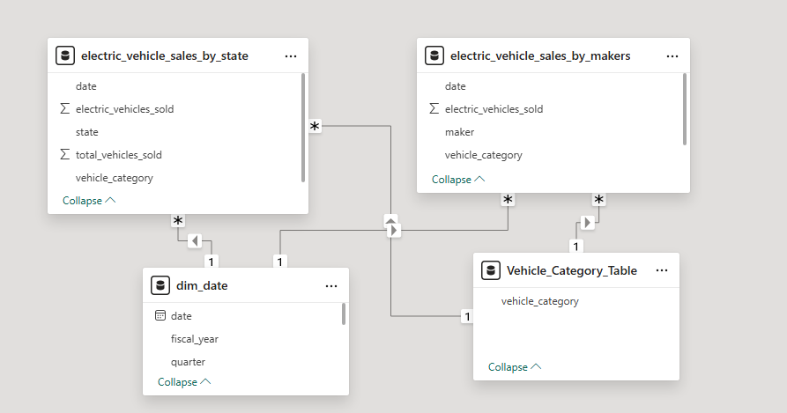

## **Executive Summary**

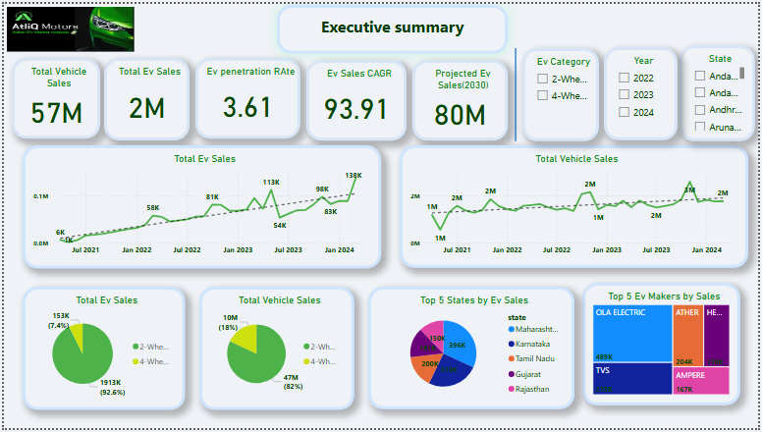

### ****Market Overview****

* India has sold over **57 million vehicles**, but only **2 million are electric**, giving an **EV penetration rate of just 3.61%**.
* EV sales are growing **extremely fast**, with a **CAGR of 93.91%** over the last few years.
* If this growth continues, EV sales could reach **80 million by 2030** — a huge opportunity for AtliQ Motors.

### ****EV Sales Breakdown****

* **2-wheelers dominate** the EV market:
  + **92.6%** of EVs sold are 2-wheelers (~1.91 million units).
  + Only **7.4%** are 4-wheelers (~153K units).
* This shows strong consumer demand for affordable, urban-friendly electric mobility.

### ****Top Performing States****

* The top 3 states — **Maharashtra, Karnataka, and Tamil Nadu** — contribute **almost 50%** of all EV sales in India.
* These states should be **priority launch markets** for AtliQ due to strong demand and policy support.

### ****Top EV Manufacturers****

* + **Ola Electric leads** the market with **23.69% share**, followed by:
  + **TVS**
  + **Ather**
  + **Hero Electric**
* These players dominate the 2W segment and set strong benchmarks for new entrants like AtliQ.

## **Sales Analysis by State**

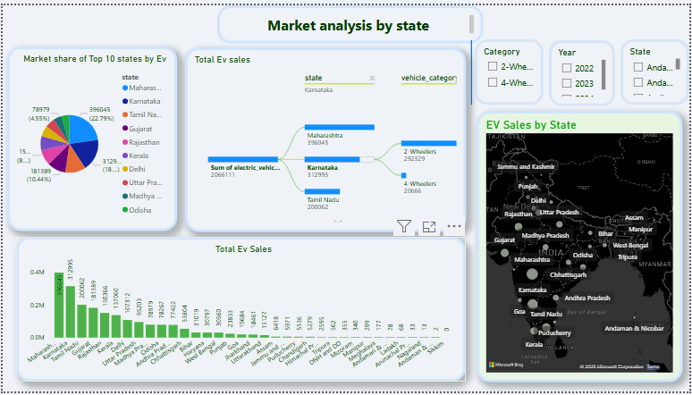

### ****Geographic Hotspots****

* **Maharashtra** leads EV adoption with **22.8%** of total EV sales, followed by:
  + **Karnataka** – 18.3%
  + **Tamil Nadu** – 10.4%
* These three states alone contribute over **50% of national EV sales**.
* In contrast, **smaller and remote states** like **Sikkim and Ladakh** have very low EV sales volumes.

### ****Vehicle Category Split****

* In all top-performing states, **2-wheelers heavily dominate**:
  + Example: **Maharashtra** sold **188K 2-wheelers** vs only **11K 4-wheelers**.
* This trend is consistent across most regions, indicating **consumer preference for 2W EVs** in urban and semi-urban areas.

### ****Map Visualization Insight****

* A regional map shows that **western and southern India** — especially **Maharashtra, Karnataka, Gujarat, and Tamil Nadu** — have the **highest EV adoption**.
* These regions likely benefit from better infrastructure, incentives, and public awareness.

## **Manufacturer Analysis**

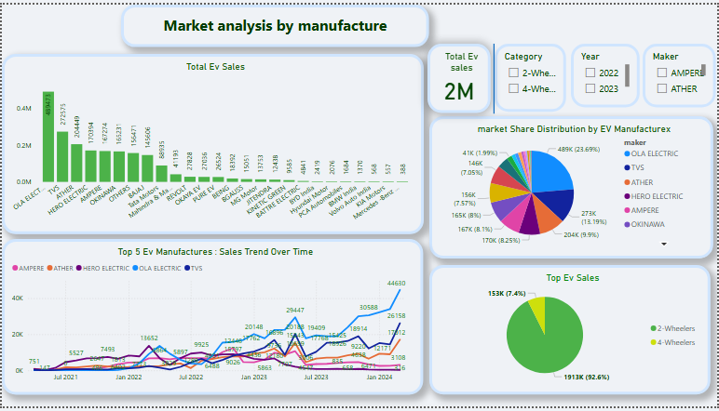

### ****Market Share****

* + **Ola Electric** leads the EV market with a strong **23.7% share**
  + **TVS** – 13.2%
  + **Ather**  – 9.9%
* **Smaller brands** like **Ampere** and **Okinawa** hold **less than 2%** each.
* The market is currently **concentrated among top 3 players**, especially in the 2-wheeler segment.

### ****Trends Over Time****

* **Ola Electric shows the sharpest growth curve**, likely driven by its **affordable and widely available 2-wheelers**.
* Most top performers are **2-wheeler companies** — this reinforces the **popularity of electric scooters** among Indian buyers.
* **No 4-wheeler manufacturers appear in the top 5**, revealing a **clear market gap and opportunity** for AtliQ Motors in the 4W EV segment.

## **Vehicle Category Deep Dive**

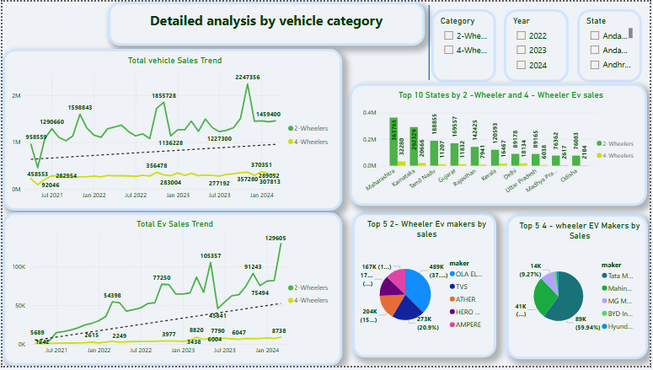

### ****2-Wheelers vs. 4-Wheelers****

* **2-wheelers dominate** the EV market with **92.6% of total sales**, while **4-wheelers make up just 7.4%**.
* This reflects the high demand for **affordable, city-friendly electric scooters**.
* Leading 2W manufacturers include:
  + **Ola Electric**
  + **TVS**
  + **Ather**

### ****State-wise Category Split****

* Even in high-performing states, **4-wheeler adoption remains low**.
* Example: In **Karnataka**, **2W sales are over 10 times higher** than 4W sales.
* This trend highlights that while 2W EVs are mainstream, **4W EVs are still in a low phase** — presenting a **growth opportunity** for AtliQ Motors

## **Monthly & Quarterly Trends**

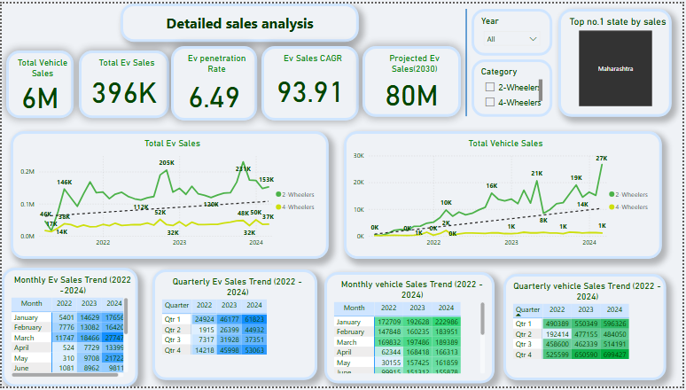

### ****Seasonality****

* EV sales show **clear seasonal peaks**:
  + **Highest in Q1 (Jan–Mar)** and **Q4 (Oct–Dec)** — likely influenced by **festive seasons, tax benefits, and year-end push**.
  + **Lowest sales occur during April–May**, possibly due to **pre-festive wait and monsoon impact**.
* This pattern is **consistent across all three years (2022–2024)**.

### ****Growth Over Time****

* EV sales have **tripled since 2022**:
  + **January 2022**: ~5.4K EVs
  + **January 2024**: ~17.6K EVs
* Quarterly sales show strong **Year-over-Year growth**:
  + **Q1 2022**: ~490K total vehicle sales
  + **Q1 2024**: ~596K total vehicle sales
* This steady growth reinforces the **market's upward momentum** and strengthens the case for AtliQ’s entry.

## **Key Recommendations for AtliQ Motors**

### ****Focus on 2-Wheelers First****

* 93% of India’s EV market is 2-wheelers (Ola, TVS dominate).
* Launch affordable, high-range models to compete.

### ****Target Top 3 States****

* Maharashtra, Karnataka, Tamil Nadu (50% of EV sales).
* Partner with local govts for incentives (e.g., subsidies, charging infra).

### ****Fill the 4-Wheeler Gap****

* 4-wheeler EVs have low competition (<8% share).
* Introduce premium SUVs/sedans (align with urban demand).

### ****Beat Competitors on Key Features****

* Offer better battery life, pricing, or charging speed than Ola/TVS.
* Highlight AtliQ’s US success in marketing.

### ****Time Launches with Peak Seasons****

* Q1 (Jan-Mar) and Q4 (Oct-Dec) see highest sales (festive demand).

### ****Leverage Rapid Market Growth****

* EV sales growing at 94% annually – early entry = market capture.

**Conclusion**

India's EV revolution is accelerating, and AtilQ Motors has a golden opportunity to establish itself as a market leader. The data clearly shows explosive growth potential, with 2-wheelers dominating today and 4-wheelers poised for future expansion.

By strategically entering with affordable 2-wheelers in high-demand states first, then introducing premium 4-wheelers as infrastructure develops, AtilQ can ride India's EV wave to success. The time to act is now - before competitors solidify their positions.

With its global expertise and the right localized strategy, AtilQ Motors is uniquely positioned to transform from a niche player to a household name in India's electric mobility future. The road ahead is clear, and the market is ready.